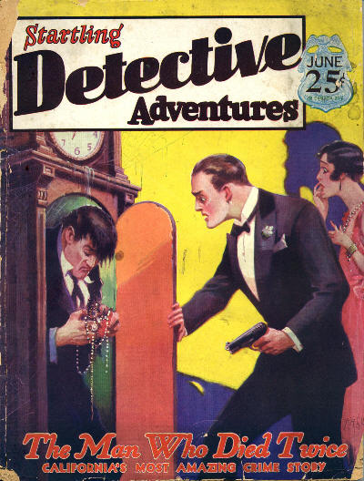

Startling Detective Adventures [Vol. 4, No. 25, June 1930]
  - 6 · The Chief’s Chair · The Editor · ed
  - 12 · Brooklyn’s Black Terror · Joseph Appelgate · ss
  - 18 · The Man Who Died Twice · Leslie T. White · ss
  - 22 · The Gallows of Doom · Wayne Sprague · ss
  - 26 · “Dingbat” Oberta’s Last Ride · [uncredited] · ss
  - 28 · The Murders in Federie Manor [Part 1 of 5] · M. G. Eberhart · sl
  - 43 · The Dirty Dude Steps Out · W. C. I. Hallowell · ss
  - 47 · The Clue Club · [uncredited] · cn
  - 48 · The Affair of the Spanish Dancer · Steuart M. Emery · ss
  - 61 · The Secret of the Scarab’s Wing · Eric Taylor · ss
  - 69 · The Mystery of the Infernal Machines · George S. Dougherty · ss
  - 73 · True Tales of a House Detective · [uncredited] · ts
  - 76 · The Death Sting Murders [Part 3 of 3] · Frederick C. Painton · sl
  - 86 · The Slaying of Old Man Lyons · Edward Anderson · ss
  - 91 · The Man Who Beat the Noose · [uncredited] · ts
  - 92 · Trailing the Missing Million · J. Frederick Funston · ss

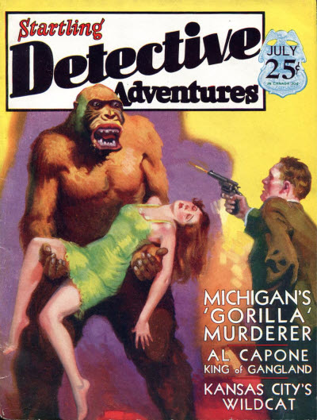

Startling Detective Adventures [Vol. 5, No. 26, July 1930]
  - 6 · The Chief’s Chair · The Editor · ed
  - 12 · The Phantom in the House of Oesterreich · Don Nachaidh · ts [Ref. Otto Sanhuber]
  - 20 · The Clue of the Rattlesnake · Herbert Hall Taylor · ts
  - 23 · Death by the ’Rod’ · [uncredited] · ar; on drive-by shootings.
  - 26 · The “Gorilla” Murderer [Part 1 of 2] · Sheriff Frank Green; as told to Jerry E. Cravey · ts
  - 32 · Al Capone, King of Gangland · Alvin E. McDermott · bg [Ref. Al Capone]
  - 36 · The Body in the Belfry · Joseph B. Wirges · ts
  - 42 · The Corpse by the Car Track · Edward Anderson · ts
  - 47 · The Masked Bomber · Edith Salt · ts
  - 50 · Kansas City’s Wildcat · Wayne Sprague · ts
  - 54 · Trapped by the Bandit Terror · A. M. Thompson · ts
  - 60 · Strange Adventures in Crime Detection: Two Watches Doom Lifer · John Westcott · ts
  - 61 · The Man with the Wounded Wrist · David Redstone · ss
  - 68 · The Pockmarked Killer · W. C. I. Hallowell · ss
  - 74 · The Murders in Federie Manor [Part 2 of 5] · M. G. Eberhart · sl
  - 86 · The Clue Club: The Mysterious Murder of Algernon Ashe · [uncredited] · cn

Обложки журналов, в которых впервые печатался роман

