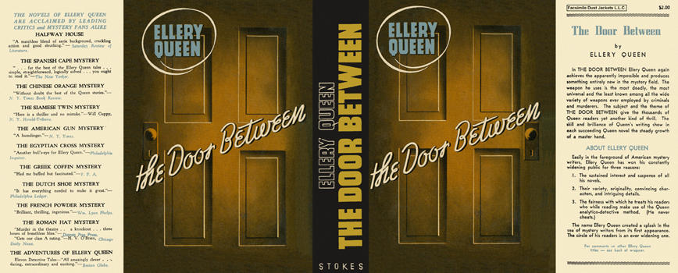

Queen, Ellery
The door between
Frederick A. Stokes Company (USA), 1937
first printing

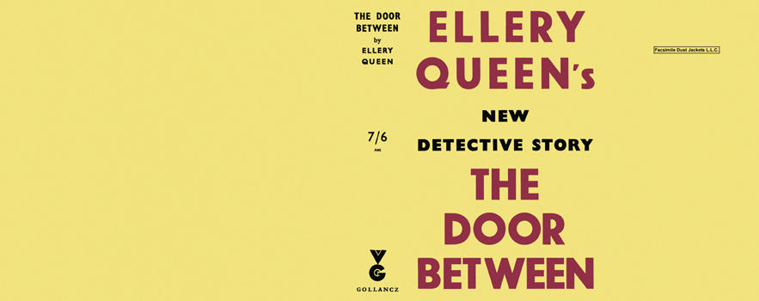

Queen, Ellery
The door between
V. G. Gollancz (UK), 1937
first printing

Суперобложки первых изданий романа

