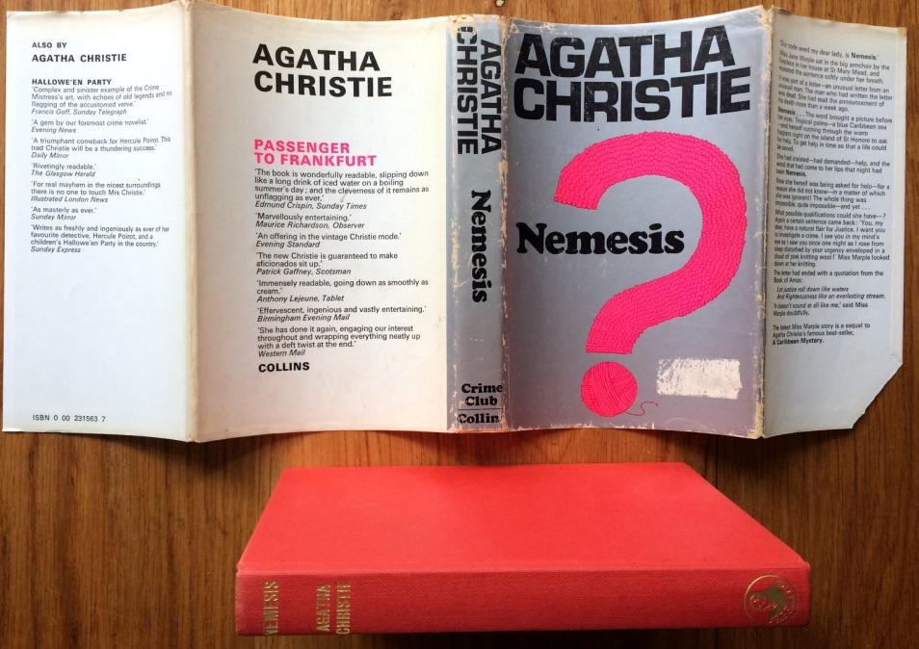

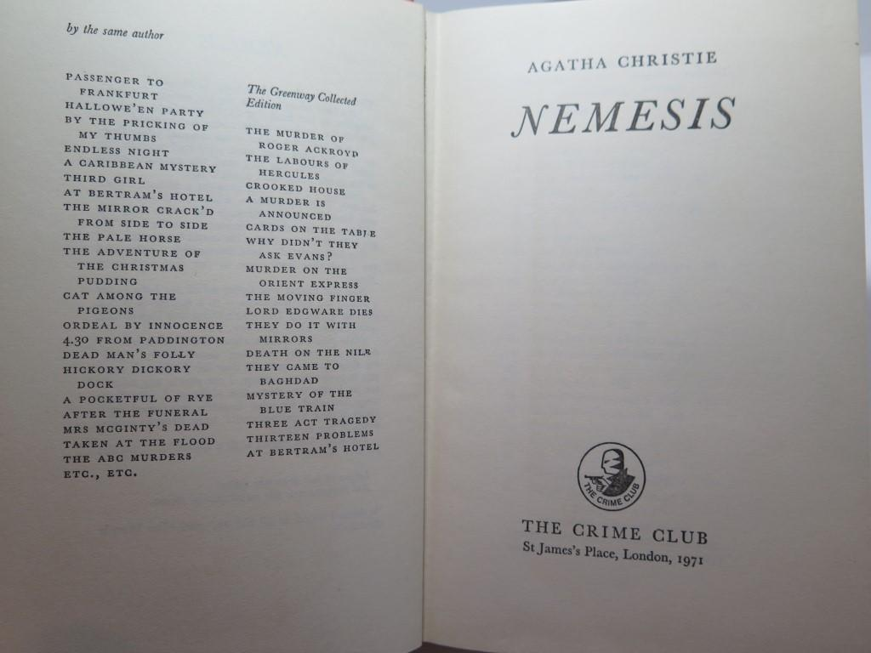

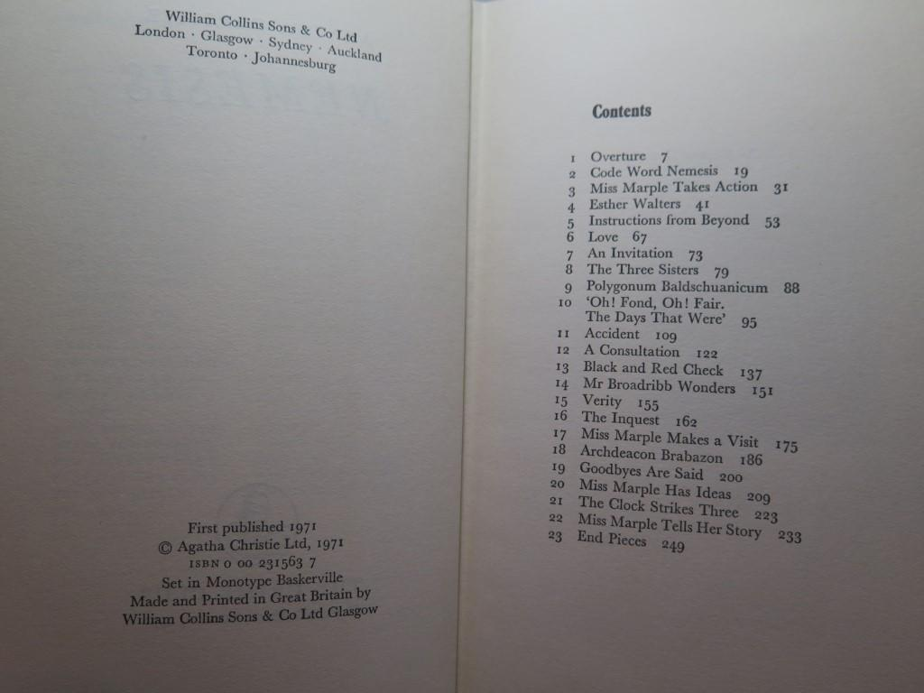

Christie, Agatha
Nemesis
Collins - The Crime Club (UK) (1971) first printing

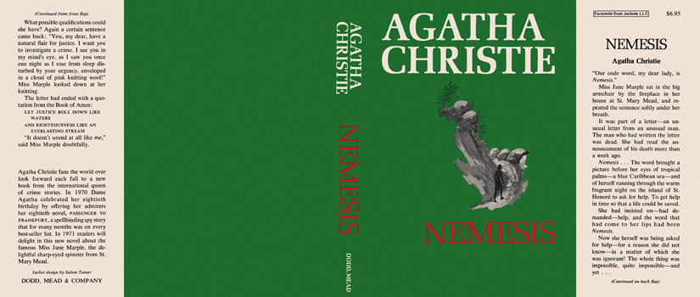

Christie, Agatha
Nemesis
Dodd, Mead & Company (USA) (1971) first printing.

Внешний вид первых изданий книги

