

Bell, Josephine

Easy Prey
London: Hodder & Stoughton, 1959 first edition

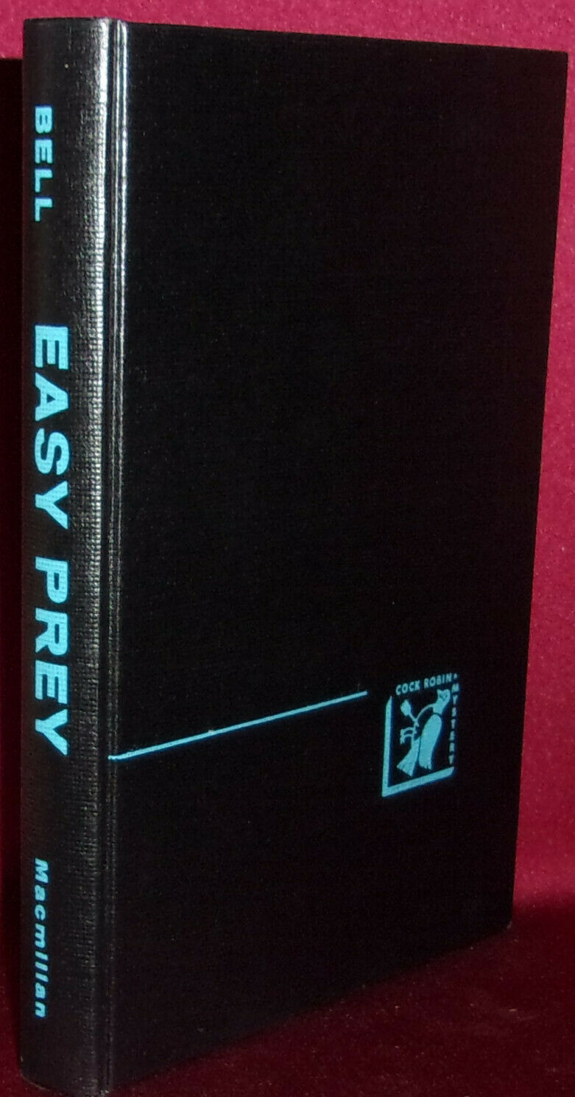

Bell, Josephine

Easy Prey
New York: The Macmillan Company, 1959 first edition

Внешний вид первых изданий книги

